DPU-BSTU Joint Institute

COURSE PROJECT
EXPLANATORY NOTE
Course name: Scripting Programming Languages
Topic: Development of a Web Application for a Dental Clinic
Student 2nd year
Group 252 ________________ Luo Ximing
signature
Supervisor
Assistant ________________ Veronica Aleshauskas
position, academic degree, academic title signature

Grade received:
Supervisor _________________ ______________ Veronica Aleshauskas
signature date name and surname

Dalian 2026
Content
Introduction 4
1 Design of the Web Application 5
1.1 Similar Solutions 5
1.2 Problem Statement 7
2 Development of the Web Application 8
2.1 Project Structure Development 8
2.2 Developing Web Pages Elements 8
3 Testing of the Web Application 13
3.1 Functional Testing 13
3.2 Responsive Design Testing 13
3.3 Cross Browser Compatibility Testing 14
3.4 Accessibility Testing 14
3.5 Performance Testing 14
3.6 Testing Summary 15
3.7 Content Issues and Remaining Work 15
Conclusion 17
Appendix A Web Application Screenshots 18
Appendix B Filtering Functionality Listing 22
Appendix C Data Verification Listing 24
Appendix D Interface State and Event Handling Listing 25

Introduction
A dental clinic website helps visitors understand available care, compare specialists, locate a branch, and find a way to contact the clinic. These tasks require clear navigation and readable information on both desktop and mobile screens. Interactive filtering and form feedback can make this information easier to use without requiring a large application framework.
The goal of this coursework is to develop and document the front-end web application for Luo Dental Clinic using HTML5, CSS3, and JavaScript. The implemented website contains six linked HTML pages. About Us and Gallery are sections of the Home page, so the eight navigation labels do not represent eight separate files.
The application demonstrates service filtering, doctor filtering, mobile navigation, appointment form validation, a contact form, and a switch between a clinic list and an interactive map. Appointment and contact submissions are demonstrations: their handlers display messages in the browser and do not send or save patient requests.
The objectives of the project are to:
1. Review the information structure of the dental websites documented in the existing project materials.
2. Define the page structure and the patient tasks supported by the application.
3. Implement semantic page markup and responsive styles using the files supplied with the project.
4. Use JavaScript arrays, filtering, DOM updates, and event listeners for interactive elements.
5. Validate form input and communicate the limits of a front-end demonstration.
6. Check the implemented interactions and responsive layouts, recording the scope and limits of the tests.
7. Prepare screenshots, source listings, and instructions for running and using the website.
The report follows the supplied explanatory-note example: design, development, testing, conclusion, and appendices. The listings and counts describe the current website files. Test results refer only to the checks actually performed for this version; broader browser, accessibility, and online-service assessments remain separate work.

1 Design of the Web Application
The website is organized around common visitor tasks: learning about the clinic, exploring treatments, finding a specialist, locating a clinic, and entering contact details. The design uses a shared clinic identity and navigation destinations while giving each page a focused purpose. The existing report also contains a comparison of dental websites, which provides the visual references below.

1.1 Similar Solutions
The comparison uses the screenshots retained in the original coursework document. It concerns visible presentation and information hierarchy. The external sites were not retested during this revision, so the screenshots do not establish their current mobile behaviour, booking capabilities, accessibility, or performance.
Yahe Dental Clinic (http://www.yahekq.com/).
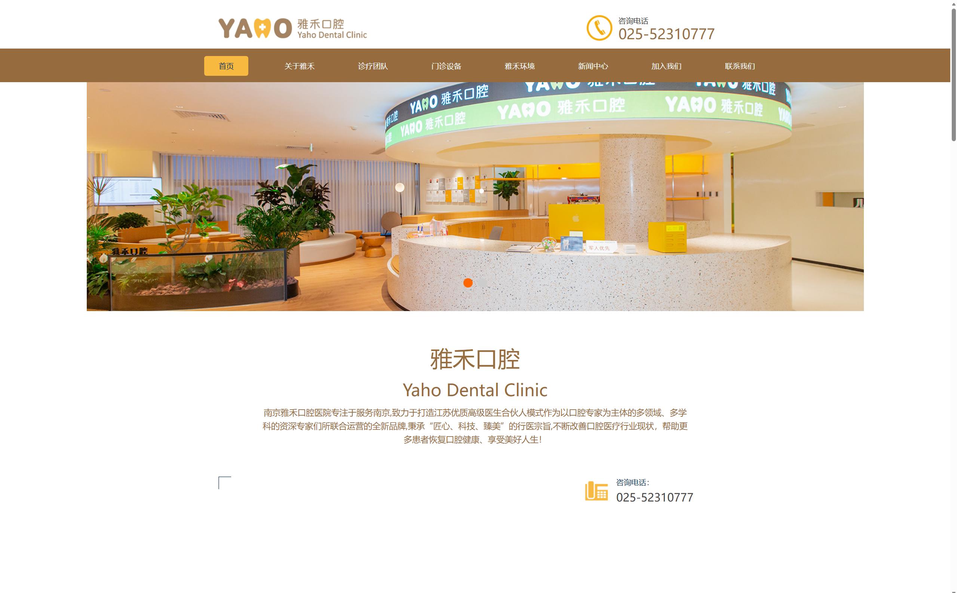
Figure 1.1 - Yahe Dental Clinic reference screenshot
The retained image places the clinic identity and an interior photograph near the top of the page. This supports the use of a recognizable clinic brand and welcoming visual material in the proposed design. For the project, treatment information and the appointment destination are also given direct navigation links.
iKang Dental (https://www.ikangdental.com/).
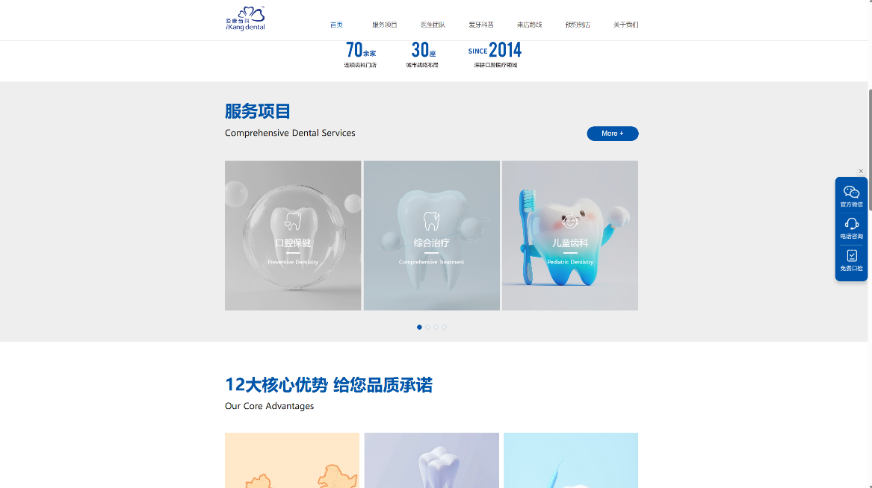
Figure 1.2 - iKang Dental reference screenshot
The existing comparison emphasizes the presentation of dental services and specialist information. The project adopts explicit treatment groups and separate specialist cards. A visitor can reduce the visible information by choosing a category rather than reading all service descriptions at once.
Stomatological Hospital of Southern Medical University (https://www.smukqyy.cn/home).

Figure 1.3 - Stomatological Hospital of Southern Medical University reference screenshot
The retained hospital screenshot contains institutional information and several content areas. The project gives practical visitor tasks their own destinations: Services, Doctors, Locations, Contacts, and Appointment. This keeps these tasks visible in a small navigation system.
These references support a clear hierarchy, visible contact details, and manageable groups of information. Their role is to inform the interface structure. Real clinic credentials, prices, and operating information require independent confirmation before public use.

1.2 Problem Statement
The required outcome is a responsive front-end website for Luo Dental Clinic. Visitors should be able to browse the supplied clinic content, filter treatments and specialists, compare branch details, and try the appointment and contact interfaces. Content and interaction are implemented in local files; the supplied project does not include a database, authentication service, administrative interface, or booking API.
Page file | Purpose
index.html | Clinic introduction, About Us, Gallery, service and doctor previews, and quick appointment form.
services.html | Nineteen services with category controls, descriptions, displayed prices, and appointment links.
doctors.html | Eight doctor records, specialist cards, and four specialization filters.
locations.html | Three branch records and list or map display controls.
contacts.html | Published contact details, opening hours, emergency information, and a demonstration contact form.
appointment.html | Detailed appointment form with required contact fields, date, service, and optional time preference.

Table 1.1 - Implemented pages and responsibilities
The main navigation includes Home, About Us, Gallery, Services, Doctors, Locations, Contacts, and Appointment. The About Us link targets index.html#about and Gallery targets index.html#photogallery. A fixed header keeps navigation accessible while scrolling. A mobile menu provides the same destinations when the desktop links are hidden.
Service categories are Preventive Dentistry, Restorative Dentistry, Orthodontics, Cosmetic Dentistry, and Implantology. The default view is All Services. Doctor controls provide All Specialists, Implantology, Orthodontics, Pediatric Dentistry, and General & Cosmetic. These labels and their corresponding data-filter values are taken directly from the HTML files.
The detailed appointment form requires full name, email address, phone number, preferred date, and service type. Preferred time is optional and provides Morning, Afternoon, and Evening radio options. The form must reject missing required input and dates before the local calendar date, then clearly state that a server-side handler is needed to create a booking.

2 Development of the Web Application
The implementation combines separate HTML and CSS files for each page with JavaScript embedded in script elements. No build step or front-end framework is required to view the local pages. Most content is stored directly in markup; services, doctors, and clinic branches use JavaScript arrays that generate repeated cards.

2.1 Project Structure Development
The web directory contains index.html, services.html, doctors.html, locations.html, contacts.html, and appointment.html. Each page links to its corresponding existing stylesheet: index.css, services.css, doctors.css, locations.css, contacts.css, or appointment.css. The Locations page links to locations.css and displays the branch cards using its local styles. The picture directory stores the local logo, clinic photographs, and doctor images. There is no separate JavaScript file in the supplied directory.
HTML5 document declarations, UTF-8 encoding, English language attributes, and viewport settings define the page foundation. The page titles identify both the current destination and Luo Dental Clinic. Headers contain the clinic identity, desktop navigation, and the burgerBtn control. The mobileMenu element is initially inert so its links cannot be reached while the menu is closed.
Each page has a main content area and footer. The homepage uses named sections including home, about, photogallery, services-preview, doctors-preview, and appointment-quick. These identifiers support section links and associate headings with their content. Other pages group service controls, specialist cards, branch views, or forms under their page heading.
The file organization makes the project easy to open and edit for coursework. Its main maintenance cost is duplication: header, footer, mobile-menu behaviour, and some contact text occur in multiple pages. A future shared layout or template could reduce inconsistent updates, but the current report describes the separate-file implementation as supplied.
The application uses plain JavaScript language features such as const, let, arrow functions, template literals, Array.filter(), Array.map(), and forEach(). These language features fit the scripting focus of the course. Browser APIs have their own compatibility requirements: inert, Element.replaceChildren(), and newer CSS features must also be considered. The use of ES2018 language constructs alone does not prove compatibility with every older browser.

2.2 Developing Web Pages Elements

2.2.1 Page Layout and Visual Styles
The homepage and Services page define CSS custom properties for their main colours and dimensions. The homepage uses --color-primary: #4e4376, --color-blue: #2b5876, --color-bg: #f5f7fb, and --content-width: 1240px. A blue-to-purple header gradient, light surfaces, rounded cards, and restrained shadows create a consistent clinic identity.
The fixed homepage header uses a high stacking level so it remains above the content. The hero contains a large headline, descriptive text, two navigation buttons, and an image. The gallery, treatment previews, and doctor previews organize repeated content into cards. Images use responsive width rules and many noncritical images use loading="lazy".
Grid and flex layouts distribute content according to available width. The Services page shows three columns on wide screens, two columns at its 1050px media rule, and a single column at 700px. The homepage changes layout at 1180px, 1050px, 760px, and 380px. Consequently, the implementation cannot be described by a single 768px breakpoint.
The desktop-to-mobile navigation change is coordinated around 1050px. Other page-specific adjustments use 768px, 760px, 700px, or 420px according to the CSS file. Reduced-motion media rules shorten animations and transitions. Keyboard focus styling is defined in the stylesheets, while controls use native button, link, input, and select elements.

2.2.2 Navigation and Scrolling
On the Appointment page, setMenuOpen(open) toggles the open class on mobileMenu, sets its inert property, and updates aria-expanded and aria-label on burgerBtn. Clicking a mobile link closes the menu. A resize handler closes it above 1050px. Other pages implement the same behaviour through their own local functions.
function setMenuOpen(open) {
mobileMenu.classList.toggle('open', open);
mobileMenu.inert = !open;
burger.setAttribute('aria-expanded', String(open));
burger.setAttribute('aria-label', open ? 'Close navigation menu' : 'Open navigation menu');
}

Listing 2.1 - Mobile menu state in appointment.html
The homepage intercepts valid internal section links and scrolls to the target with smooth behaviour. A floating return-to-top control responds to scrolling and calls window.scrollTo({ top: 0, behavior: 'smooth' }). The display threshold differs between pages, so it is a local presentation decision rather than one global application setting.

2.2.3 Service Rendering and Filtering
servicesData contains nineteen records. Each record has the exact fields id, name, category, icon, desc, price, and link. categoryLabels translates category values into visible treatment names. The category values are preventive, restorative, ortho, cosmetic, and implant. All records link to appointment.html; selecting a service does not prefill the detailed booking form.
renderServices(filter = "all") chooses the full array or filters by strict category equality. It clears servicesGrid with replaceChildren(), creates an article for each service, and adds its icon, category, title, description, displayed price, and appointment link. textContent is used for the text fields. resultsCount then reports the number of visible services.
function renderServices(filter = "all") {
const filteredServices = filter === "all"
? servicesData
: servicesData.filter(service => service.category === filter);

servicesGrid.replaceChildren();

Listing 2.2 - Service selection and container reset in services.html
Each filter button has a data-filter attribute. Its click handler updates the active class and aria-pressed on every filter button, then passes button.dataset.filter to renderServices(). The default All Services view contains nineteen cards; the category counts are four preventive, four restorative, three orthodontic, four cosmetic, and four implant services.

2.2.4 Doctor Data and Specialist Filters
doctorsData contains eight records with the exact fields id, name, specialty, category, experience, bio, imgPlaceholder, and contact. experience is stored as text, such as "2 years". The rendering function reads specialty to display the specialization.
renderDoctors(filter = "all") selects the complete array or calls doctorsData.filter(doc => doc.category === filter). The selected records are converted to HTML cards with map() and join(). The resulting string is assigned to doctorsGrid.innerHTML. A card includes a local image, name, specialty, experience, biography, and mailto link. Failed images use an external placeholder URL.
initFilters() attaches click listeners to the filter buttons. A click removes the active class from all buttons, adds it to the selected button, reads its data-filter attribute, and renders the chosen category. The four specific categories each contain two doctors. The supplied data are trusted local coursework content; introducing untrusted remote text would require reviewing the use of HTML string interpolation.

2.2.5 Appointment and Contact Validation
The homepage quickAppointmentForm contains appName, appEmail, appPhone, appService, and appDate. Name, email, and phone are marked required. The custom submit handler trims their values, requires at least two name characters, applies an email regular expression, and requires at least six phone characters. showFieldError() updates the corresponding error element and input state.
When a quick-form error occurs, appFeedback displays an error summary and focus moves to the first input with the invalid class. On valid input, the handler greets the visitor by the first name and states that no information was sent to a server. It resets the form and clears the field errors. appDate has a local-date minimum, but the custom submit handler does not call checkValidity() or independently reject an earlier selected date. Date validation on the homepage therefore differs from the detailed Appointment page.
The detailed appointmentForm uses novalidate to let its JavaScript handler control reporting. The handler prevents default submission, clears formStatus, calls checkValidity(), and uses reportValidity() to display browser validation when needed. It then trims fullName, email, and phone and checks the required preferredDate and serviceType values.
The date minimum is derived from the local calendar date using the timezone offset before converting to an ISO date string. The detailed form therefore rejects a date earlier than its min value through the browser validity API. It does not implement phone-number format validation beyond the nonempty requirement. The optional timeSlot radio group expresses a preference and is not a live schedule or availability lookup.
The final detailed-form message explicitly says the demonstration does not send or save requests. It is written to formStatus and focused. The static introductory text mentions confirmation within 24 hours, but no code contacts the clinic or enforces that promise. This text is a content issue to resolve before any public release.
The Contacts page uses contactForm with contactName, contactEmail, contactPhone, and contactMsg. Name, email, and message are required, while phone is optional. Native HTML validation handles required and email validity, and the JavaScript handler also rejects whitespace-only required text after trimming. A valid demonstration updates formFeedback and does not send a message. There is no fetch(), XMLHttpRequest, or form-processing endpoint in these handlers.

2.2.6 Clinic List and Map View
The locations array contains three branch records. The exact fields are id, name, address, phone, email, hours, lat, lng, image, and description. renderListView() displays the records in locationsListContainer. List mode is the initial view; mapContainer is initially hidden.
showMap() switches the visible containers and button states, then calls initMap() on first use. The page includes Leaflet 1.9.4 from unpkg.com. initMap() creates a map centered at [53.9045, 27.5615], adds CartoDB tiles, and places one marker per branch using lat and lng. Popups contain the branch name, address, phone, and an appointment link.
mapInitialized and map prevent repeated map construction. When an existing map is shown again, requestAnimationFrame() schedules invalidateSize() so Leaflet can recalculate the visible container dimensions. If the Leaflet global L is unavailable, the page displays a message asking the visitor to check the internet connection and reload. This fallback was exercised during the offline test.
The Leaflet script and stylesheet are declared in the page head or body and can be requested before the visitor opens map mode. Only map construction is deferred until the map button is clicked. Font Awesome, branch images, image fallbacks, and map tiles also depend on external resources; the website is therefore not completely self-contained for offline viewing.

2.2.7 Running and Using the Website
1. Keep the entire web directory, including the picture directory and all CSS files, together. Open web/index.html in a modern browser. The local-file method was used for the recorded checks.
2. Use the header to open a page. About Us and Gallery move to the corresponding homepage sections. On a narrow screen, use the menu button to reveal the same destinations.
3. Open Services and select a treatment category. All Services restores the nineteen-card view. Use an appointment link to open the detailed form.
4. Open Doctors and choose a specialization. All Specialists restores the eight-record view. A doctor email link opens the configured email application; the website itself does not deliver email.
5. Open Locations to compare the three branch cards. Map mode needs working external resources. If the map cannot load, return to List mode to read the supplied branch information.
6. Enter contact values and choose a service in the Appointment page. Correct any browser validation prompts. A valid form displays demonstration feedback and creates no real appointment.
7. Use Contacts for the supplied telephone and email links or try the message form. The form confirms validation only. Reloading does not restore previously entered request data through application storage.

3 Testing of the Web Application
The checks were performed on 20 October 2026 against the supplied local web files using automated Playwright control of Google Chrome 155.0.8059.84. External HTTP and HTTPS requests were deliberately blocked. This setup verifies the local interface and its response to unavailable external resources; it does not verify live map tiles, CDN delivery, placeholder images, email delivery, or server-side processing.
The evidence is recorded in work/web-checks.json and the automated procedure in work/check_web.cjs. The run produced twenty-one passing interaction checks, thirty viewport measurements, and no recorded pageerror events. A separate reference audit, recorded in work/local-reference-check.json, found no missing local files among the static src and href references in the six HTML pages. The screenshots in Appendix A come from the same local offline setup.

3.1 Functional Testing
The service test clicked All Services and every treatment filter and counted the generated .service-card elements. The observed counts were 19, 4, 4, 3, 4, and 4 in the order all, preventive, restorative, ortho, cosmetic, and implant. The doctor test clicked all, implant, ortho, pediatric, and general and counted 8, 2, 2, 2, and 2 .doctor-card elements.
For each of the six pages, the mobile-menu test opened burgerBtn at a 390px viewport and checked aria-expanded="true". It then followed the first mobile link and checked aria-expanded="false". These twelve checks confirmed the tested opening and closing sequence. They do not constitute a complete keyboard or focus-order audit.
Submitting the empty homepage quick form produced three invalid inputs and an error summary. Entering a test name, an email address, and a phone number produced the expected demonstration feedback. On the detailed Appointment page, an empty form failed validity, a date of 2000-01-01 produced rangeUnderflow, and a valid date equal to the input minimum produced the no-send and no-save message.
The contact test entered the required values and confirmed its demonstration feedback. The location test counted three cards, opened Map mode with Leaflet unavailable, checked the map-loading message, and returned to the visible list. These checks exercise defined interface paths; they do not prove every validation edge case or successful online map initialization.

3.2 Responsive Design Testing
All six pages were measured at viewport widths of 1440, 1051, 1050, 768, and 390 CSS pixels, with a viewport height of 1000 pixels. These widths include both sides of the 1050px navigation breakpoint. At every measurement, document.documentElement.scrollWidth was no greater than clientWidth, so no horizontal document overflow was detected in the thirty tested combinations.
The desktop screenshots show the header, page heading, and initial content. The Locations screenshot includes its styled branch cards and view controls. A separate mobile homepage screenshot records the narrow layout. The Locations page was included in the five-width measurements with locations.css linked. Automated width checks establish the absence of measured overflow at those dimensions, rather than complete visual correctness at every scroll position, pixel ratio, orientation, or physical device.

3.3 Cross Browser Compatibility Testing
The recorded browser run covers Google Chrome 155.0.8059.84 only. Microsoft Edge, Mozilla Firefox, Safari, and Opera were not executed for this revision. Compatibility with those browsers remains an acceptance task. Their checks should repeat navigation, filters, native form validation, the inert mobile menu, layout boundaries, and online map interactions.
Browser testing should consider DOM APIs and CSS support independently of JavaScript syntax. In particular, inert, replaceChildren(), dynamic viewport units, and modern layout functions require appropriate support in the target browser. The report therefore does not claim a completed cross-browser compatibility assessment.

3.4 Accessibility Testing
Source inspection found input labels, descriptive button labels, aria-expanded on mobile-menu controls, and status regions for form feedback. Service filter buttons update aria-pressed. The inactive mobile menu uses inert. Reduced-motion CSS rules are present, and page elements include native links, buttons, forms, and headings.
These are implemented accessibility measures, rather than a certification result. A full keyboard-only walkthrough, screen-reader assessment, contrast measurement, and systematic heading audit were not performed. Source inspection also shows that the Doctors page filter controls do not update aria-pressed in the same way as the Services page; this is a specific improvement for future work.

3.5 Performance Testing
The current project uses local image assets, external stylesheets, inline scripts, and arrays containing nineteen services, eight doctors, and three branches. Lazy loading is specified for many images. The map instance is created on demand and reused. These implementation details explain how work is organized, but they are not measured performance results.
No Lighthouse score, network-load timing, rendering benchmark, or Core Web Vitals measurement was collected. Because the test blocked external requests, it cannot provide a normal online load time. Performance acceptance should be measured with the intended hosting configuration, realistic network conditions, and external resources available. It should also include a separate test of graceful behaviour when those resources fail.

3.6 Testing Summary
Test area | Recorded result | Scope
Service filters | Passed | 6 selections; 19 total services and correct category counts.
Doctor filters | Passed | 5 selections; 8 total doctors and 2 per category.
Mobile navigation | Passed | Open and close sequence on all 6 pages.
Quick form | Passed | Empty required values rejected; valid test values show demo feedback.
Detailed appointment | Passed | Missing values, past date, and valid demonstration path checked.
Contact form | Passed | Valid values produce a no-delivery demonstration message.
Locations | Passed | 3 cards, unavailable-map message, and return to list checked.
Horizontal overflow | Not detected | 30 page and viewport combinations measured.
JavaScript page errors | None recorded | Local tested paths with external requests blocked.
Local file references | Passed | Static src and href references resolve to existing local files.
Other browsers | Not tested | Requires separate browser runs.
Online map and CDN | Not tested | Only the unavailable-library path was exercised.
Accessibility and speed | Partial review | Source review only; no conformance or timing result.

Table 3.1 - Verification results and limits
The recorded checks support the local navigation, filtering, form-feedback, and narrow-layout behaviour described above. They also expose the need to keep implementation limits clear: a form validation message is not a booking, a map-loading fallback is not a successful map connection, and one browser run is not a compatibility assessment.

3.7 Content Issues and Remaining Work
The homepage footer displays "123 Health Street, Chengdu", while the Contacts page and branch data describe locations in Minsk. The homepage statistics state "15 Dental specialists", but doctorsData contains eight records. These are different statements in the current source and require editorial reconciliation; this document does not invent a replacement address or staffing number.
The location email strings include citycenter@Luo Dental Clinic.by, north@Luo Dental Clinic.by, and south@Luo Dental Clinic.by. Their spaces make them unsuitable as ordinary mailbox addresses. The doctor records instead use the dentacare.by domain, while Contacts uses Luo.by. The supplied sources do not establish which domain or branch addresses are authoritative.
The homepage social links use href="#" and are accompanied by a note that real profiles must be connected. Contacts says official links will be added when available. Branch images are external placeholders. These items should be replaced with confirmed content before publication. The current report keeps them visible as implementation limits rather than treating them as completed integrations.
Further technical work includes consistent date validation on the quick form, clearer synchronization between service links and service selection, consistent accessibility state on doctor filters, and real form handling if genuine appointment requests become part of the requirements. Each change should be verified with new tests. The webpage files themselves were not modified during this documentation revision.

Conclusion
The coursework produced a six-page front-end website for Luo Dental Clinic and a documented account of its actual implementation. The pages present clinic information, a gallery, treatment records, specialist profiles, branch details, contact information, and appointment interfaces. About Us and Gallery are homepage sections reached through navigation anchors.
The scripting work demonstrates array-based content, strict category filtering, DOM construction, HTML rendering, event listeners, input validation, and interface state changes. The Services page contains nineteen services in five categories, and the Doctors page contains eight specialists in four filter groups. The Locations page provides three branch cards and Leaflet-based map controls with an unavailable-library message.
The homepage and detailed appointment forms use different validation paths. Both provide local feedback, while the contact form similarly demonstrates validation without delivery. The supplied application includes no booking server, database, authentication system, or persistent patient request storage. These limits define the current coursework scope.
The recorded Chrome run passed twenty-one interaction checks and detected no horizontal overflow in thirty page and viewport combinations. No JavaScript page errors were recorded on the tested paths. The static resource audit found no missing local files in HTML src and href references, including the Locations stylesheet. External resources were blocked, so live map operation and normal online loading were not established. Other browsers, complete accessibility assessment, and performance measurement remain to be tested.
The principal remaining content work is to reconcile addresses, staffing figures, email domains, and placeholder social links using confirmed clinic information. Future functional development can connect a server-side form handler and improve shared components and validation consistency. The report, screenshots, and source appendices provide a reviewable basis for those changes without claiming that demonstration actions create real medical appointments.

Appendix A
Web Application Screenshots
The following images are actual viewport captures from the local Chrome test with external HTTP and HTTPS resources blocked. Local images and layout are shown; externally supplied icons, branch pictures, and map resources are unavailable in this test environment.
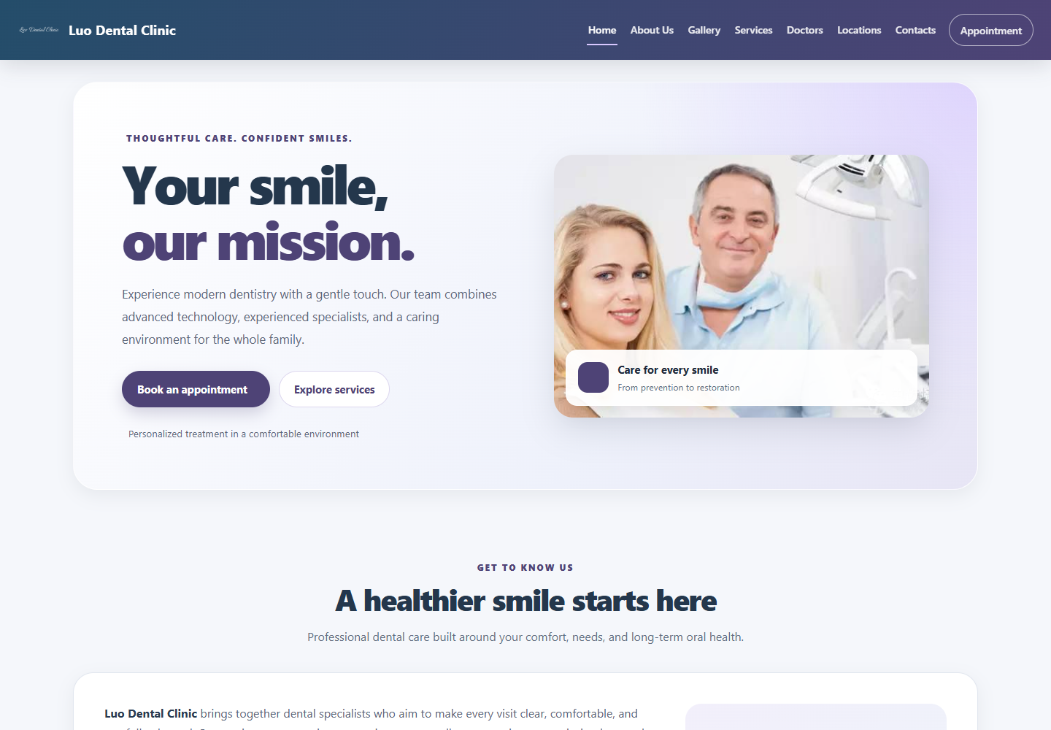
Figure A.1 - Home page at 1440 by 1000 pixels
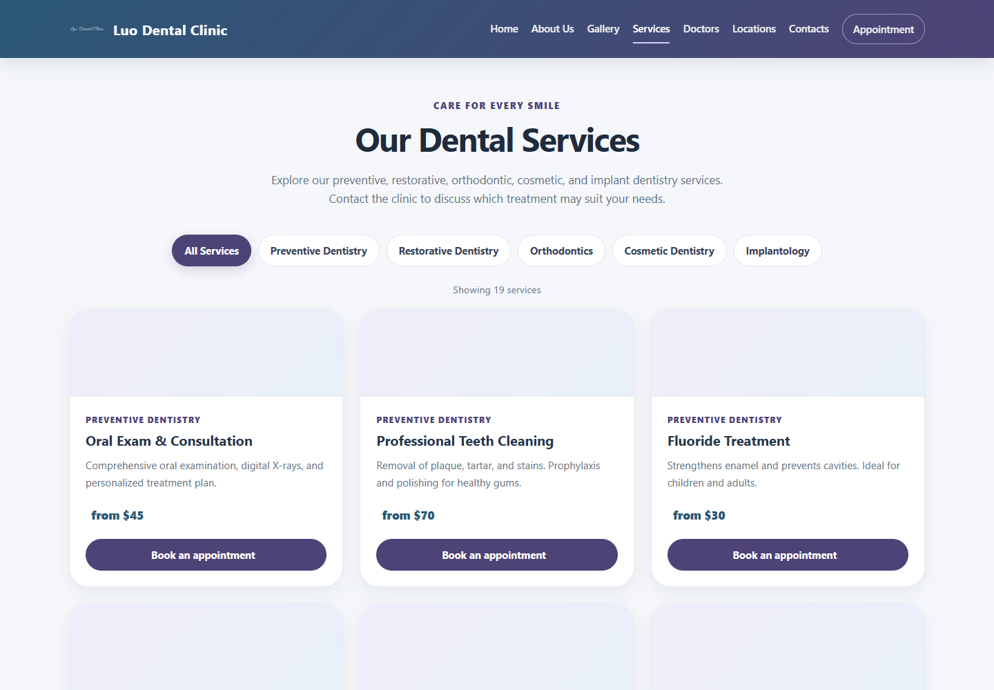
Figure A.2 - Services page with nineteen available records

Figure A.3 - Doctors page with specialist filter controls
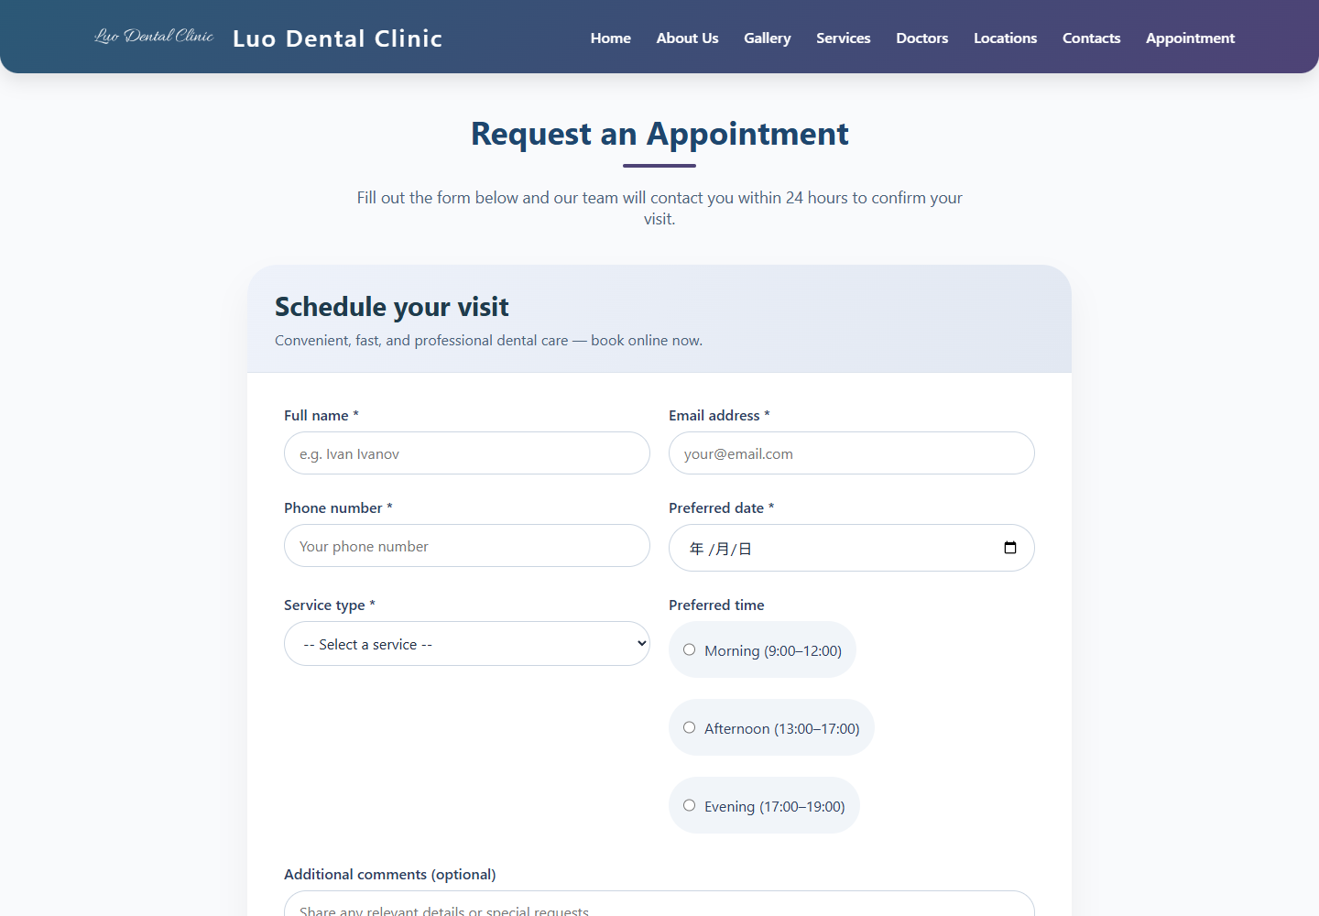
Figure A.4 - Detailed appointment form
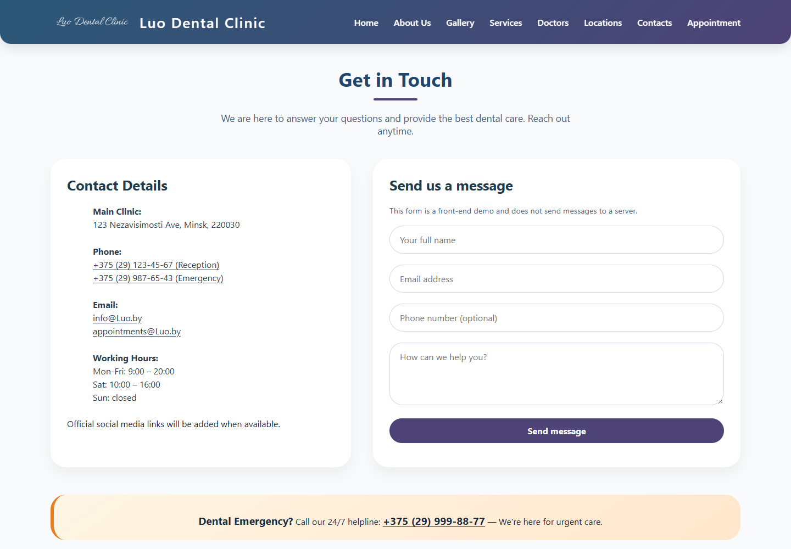
Figure A.5 - Contacts page and demonstration message form
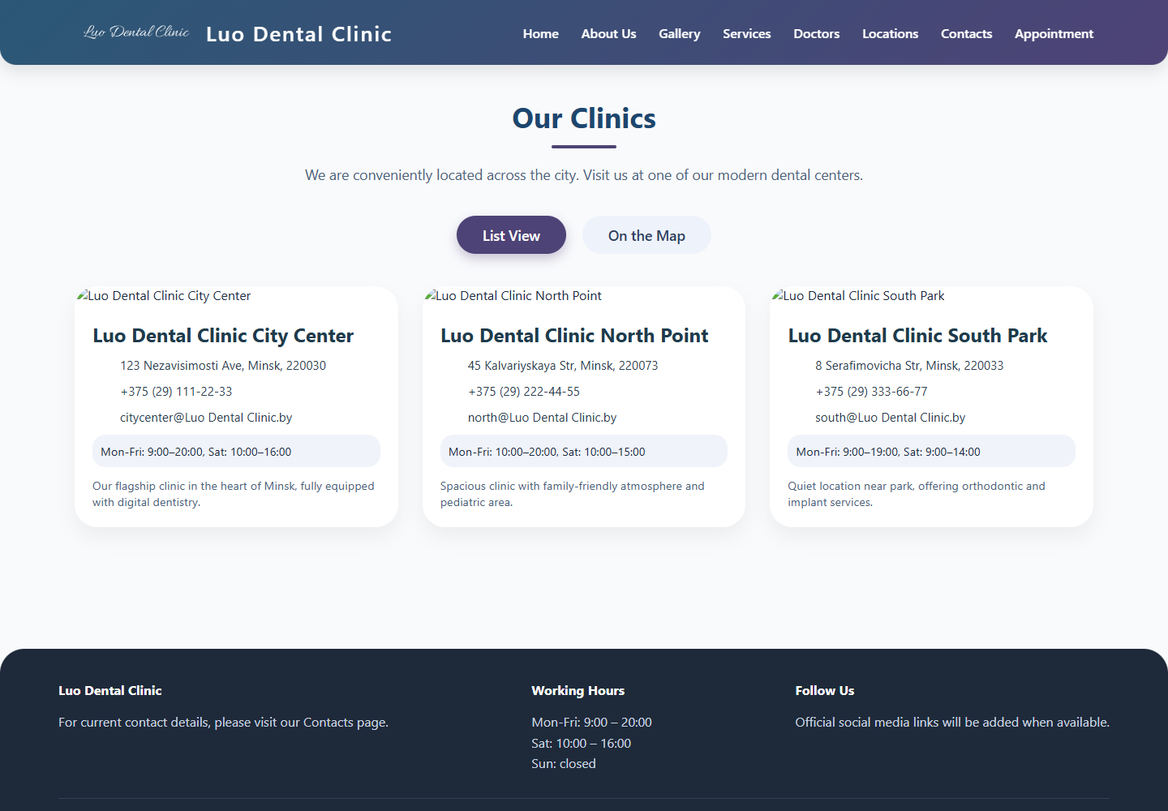
Figure A.6 - Styled Locations list view with external images unavailable

Figure A.7 - Home page at 390 by 1000 pixels

Appendix B Filtering Functionality Listing
The excerpts below are copied from the current source files. The service rendering function is shown in full, followed by doctor rendering and the doctor filter event setup. All identifiers retain their source spelling.
Listing B.1 - renderServices from services.html
function renderServices(filter = "all") {
const filteredServices = filter === "all"
? servicesData
: servicesData.filter(service => service.category === filter);

servicesGrid.replaceChildren();

filteredServices.forEach(service => {
const card = document.createElement("article");
card.className = "service-card";

const iconWrap = document.createElement("div");
iconWrap.className = "service-icon";
iconWrap.setAttribute("aria-hidden", "true");
const icon = document.createElement("i");
icon.className = service.icon;
iconWrap.appendChild(icon);

const content = document.createElement("div");
content.className = "service-content";

const category = document.createElement("p");
category.className = "service-category";
category.textContent = categoryLabels[service.category];

const title = document.createElement("h2");
title.textContent = service.name;

const description = document.createElement("p");
description.className = "service-desc";
description.textContent = service.desc;

const price = document.createElement("p");
price.className = "service-price";
const priceIcon = document.createElement("i");
priceIcon.className = "fa-solid fa-tag";
priceIcon.setAttribute("aria-hidden", "true");
price.append(priceIcon, document.createTextNode(" " + service.price));

const link = document.createElement("a");
link.href = service.link;
link.className = "book-link";
link.innerHTML = 'Book an appointment <i class="fa-solid fa-arrow-right" aria-hidden="true"></i>';

content.append(category, title, description, price, link);
card.append(iconWrap, content);
servicesGrid.appendChild(card);
});

resultsCount.textContent = `Showing ${filteredServices.length} service${filteredServices.length === 1 ? "" : "s"}`;
}

Listing B.2 - renderDoctors and initFilters from doctors.html
function renderDoctors(filter = "all") {
const grid = document.getElementById("doctorsGrid");
if (!grid) return;

let filtered = doctorsData;
if (filter !== "all") {
filtered = doctorsData.filter(doc => doc.category === filter);
}
if (filtered.length === 0) {
grid.innerHTML = `<div style="text-align:center; grid-column:1/-1; padding:40px;">No doctors found in this category. Please try another filter.</div>`;
return;
}
const cardsHTML = filtered.map(doc => `
<div class="doctor-card" data-category="${doc.category}">
<img class="doctor-img" src="${doc.imgPlaceholder}" alt="${doc.name}" loading="lazy" onerror="this.onerror=null; this.src='https://placehold.co/400x320?text=Dentist';">
<div class="doctor-info">
<h3>${doc.name}</h3>
<div class="doctor-specialty">${doc.specialty}</div>
<div class="doctor-experience"><i class="fas fa-briefcase" aria-hidden="true"></i> ${doc.experience} experience</div>
<div class="doctor-bio">${doc.bio}</div>
<div class="doctor-contact"><i class="fas fa-envelope" aria-hidden="true"></i> <a href="mailto:${doc.contact}">${doc.contact}</a></div>
</div>
</div>
`).join('');

grid.innerHTML = cardsHTML;
}

// Setup filter buttons event listeners
function initFilters() {
const buttons = document.querySelectorAll('.filter-btn');
buttons.forEach(btn => {
btn.addEventListener('click', function() {
// remove active class from all
buttons.forEach(b => b.classList.remove('active'));
this.classList.add('active');
const filterValue = this.getAttribute('data-filter');
renderDoctors(filterValue);
});
});
}

Appendix C Data Verification Listing
This excerpt contains the date minimum and submit handler used on the detailed Appointment page. It validates browser constraints and required trimmed values before displaying the explicit demonstration message.
Listing C.1 - Appointment validation from appointment.html
const appForm = document.getElementById('appointmentForm');
const formStatus = document.getElementById('formStatus');
const dateInput = document.getElementById('preferredDate');

// Use the local calendar date rather than UTC to avoid timezone date shifts.
const now = new Date();
const localToday = new Date(now.getTime() - now.getTimezoneOffset() * 60000)
.toISOString().slice(0, 10);
dateInput.min = localToday;

appForm.addEventListener('submit', (event) => {
event.preventDefault();
formStatus.textContent = '';

if (!appForm.checkValidity()) {
appForm.reportValidity();
return;
}

const fullName = document.getElementById('fullName').value.trim();
const email = document.getElementById('email').value.trim();
const phone = document.getElementById('phone').value.trim();
const preferredDate = dateInput.value;
const service = document.getElementById('serviceType').value;

if (!fullName || !email || !phone || !preferredDate || !service) {
formStatus.textContent = 'Please complete all required fields.';
formStatus.focus();
return;
}

formStatus.textContent =
'The form passed basic validation, but this demo page does not send or save requests. A server-side form handler is required to book an appointment.';
formStatus.focus();
});

Listing C.2 - Contact form handler from contacts.html
const contactForm = document.getElementById('contactForm');
const formFeedback = document.getElementById('formFeedback');
if (contactForm && formFeedback) {
contactForm.addEventListener('submit', event => {
event.preventDefault();
const name = document.getElementById('contactName').value.trim();
const email = document.getElementById('contactEmail').value.trim();
const message = document.getElementById('contactMsg').value.trim();

if (!name || !email || !message) {
formFeedback.textContent = 'Please complete all required fields.';
return;
}

formFeedback.textContent = 'This demo form is validated, but it cannot send your message until a server-side form handler is connected.';
});
}

Appendix D Interface State and Event Handling Listing
The website stores view state in its controls and page-local variables. It does not implement the music-store cart, wishlist, or persistent theme state shown in the reference example. The following actual source excerpts cover mobile-menu state and location view switching.
Listing D.1 - Mobile navigation from appointment.html
const burger = document.getElementById('burgerBtn');
const mobileMenu = document.getElementById('mobileMenu');

function setMenuOpen(open) {
mobileMenu.classList.toggle('open', open);
mobileMenu.inert = !open;
burger.setAttribute('aria-expanded', String(open));
burger.setAttribute('aria-label', open ? 'Close navigation menu' : 'Open navigation menu');
}

burger.addEventListener('click', () => {
setMenuOpen(burger.getAttribute('aria-expanded') !== 'true');
});

mobileMenu.querySelectorAll('a').forEach((link) => {
link.addEventListener('click', () => setMenuOpen(false));
});

window.addEventListener('resize', () => {
if (window.innerWidth > 1050) setMenuOpen(false);
});

Listing D.2 - Location view state from locations.html
let mapInitialized = false;
let map = null;
let markers = [];

function showList() {
document.getElementById('locationsListContainer').classList.remove('hidden');
document.getElementById('mapContainer').classList.add('hidden');
document.getElementById('listModeBtn').classList.add('active');
document.getElementById('mapModeBtn').classList.remove('active');
document.getElementById('listModeBtn').setAttribute('aria-pressed', 'true');
document.getElementById('mapModeBtn').setAttribute('aria-pressed', 'false');
// optional: resize map if needed later, but not needed
}

function showMap() {
document.getElementById('locationsListContainer').classList.add('hidden');
document.getElementById('mapContainer').classList.remove('hidden');
document.getElementById('listModeBtn').classList.remove('active');
document.getElementById('mapModeBtn').classList.add('active');
document.getElementById('listModeBtn').setAttribute('aria-pressed', 'false');
document.getElementById('mapModeBtn').setAttribute('aria-pressed', 'true');
// initialize map if not yet
if (!mapInitialized) {
initMap();
} else if (map) {
requestAnimationFrame(() => map.invalidateSize());
}
}

